**User Manual For Chatbot.**

**This Chatbot is on a very primitive stage. Its takes in questions through input box and Outputs its answers as audio.**

**Home Page**

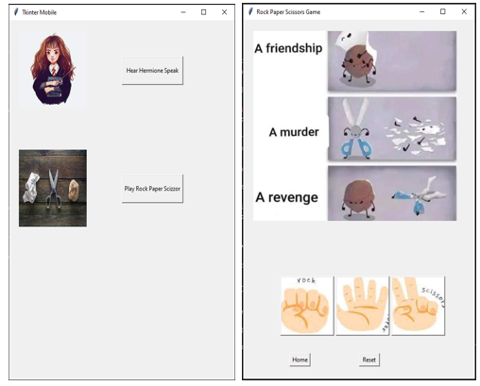

Click here for the RockPaperScissor Game

Click here for the chatbot

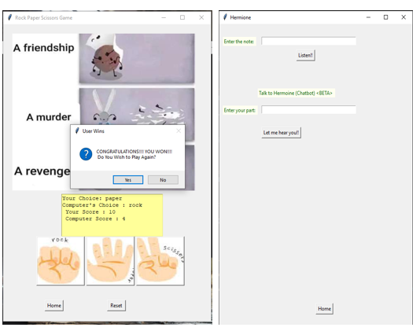

Click here to go to HomePage

Click here to listen to hermione’s answer to that question

Enter your question whatever you want to ask to Hermione.

Click here to listen the generated audio

Enter the text that you want chatbot Hermione to say



Click here to go to homepage

Click here to reset the score and restart the match

Click any of the three buttons(Rock Paper Scissor) to select your choice.

Computer’s choice is autogenerated pseudorandom selection

The player who scores 10 points first wins.

So appropriate message is displayed and user’s choice is applied.

If Yes is selected the game restarts and if No is selected control flows back to HomePage